|  |
| --- |
| **UNIVERSITY OF ECONOMICS AND LAW**  FACULTY OF INFORMATION SYSTEM  -----🙞🙜🕮🙞🙜-----  **ANALYSIS AND DESIGN OF MANAGEMENT INFORMATION SYSTEMS**    **TOPIC:**  **WeMed - A Mobile application allows patients to register for medical examination at the hospital**  **Instructor: Ms. Vu Thuy Hang**    **Member:**  **1.** Nguyễn Thành Luân K214160991  **2.**  **3.**  **4.**  **5.**  **Ho Chi Minh City, November 14th, 2023** |

**ACKNOWLEDGEMENT**

First and foremost, we would like to express our sincere gratitude to the University of Economics and Law for incorporating Information system analysis and design into the curriculum. In particular, we want to extend our deep appreciation to our research advisor and course lecturer - Master Vu Thuy Hang, Dr. Le Thi Kim Hien and Master Tran Thi Anh, for their dedicated guidance and imparting invaluable knowledge to us throughout the recent study period. During our participation in the Information system analysis and design class, we have accumulated additional useful knowledge, enhanced analytical abilities, and fostered a spirit of serious and effective learning. Their enthusiasm and dedication have been a significant source of motivation that has helped us complete this essay thoroughly. Without their encouragement and guidance, this essay could not have been executed as efficiently and meticulously as it has.

Information system analysis and design course is an interesting and extremely useful subject with a high application of specialized knowledge, ensuring sufficient relevance to students' professional disciplines. We have endeavored to complete this essay to the best of our abilities, utilizing textbook knowledge and the experience we have accumulated. However, due to limitations in knowledge capital and the ability to gather real-world data, there are still many surprises. Despite our best efforts, it is certain that the essay may have shortcomings and incomplete aspects. Therefore, our group looks forward to receiving suggestions and sharing from teachers so that the group's plan can become more refined.

We wish everyone good health and much success in their teaching careers.

Thank you!

**TABLE OF MEMBERS CONTRIBUTION**

|  |  |  |  |
| --- | --- | --- | --- |
| TT | Full name | ID Student | Contribution percentage |
| 1 | Nguyễn Thành Luân | K214160991 | 100% |
| 2 |  |  |  |
| 3 |  |  |  |
| 4 |  |  |  |
| 5 |  |  |  |

**TABLE OF CONTENT**

**CHAPTER 1: PROJECT OVERVIEW 6**

1.1 Introduction 7

1.2 Detailed Objectives 8

1.3 Function Lists 8

1.3.1 Login and Sign up 8

1.3.2 Manage Patient Profile 9

1.3.3 Booking 10

1.3.4 Payment 11

1.3.5 Refund 11

1.3.6 View booking schedule 12

**Chapter 2. Overall Descriptions 14**

2.1 Descriptions 14

2.2 Overall Flow (BPMN) 14

2.3 Login and Sign up 15

2.3.1 BPMN 15

2.3.2 Detailed Flow 16

2.4 Manage Patients Profile 17

2.4.1 BPMN 18

2.4.2 Detailed Flow 19

2.4 Booking 20

2.4.1 BPMN 20

2.4.2 Detailed Flow 21

2.5 View Booking Schedule 24

2.5.1 BPMN 24

2.5.2 Detailed Flow 24

2.6 Payment 26

2.6.1 BPMN of Payment 26

2.6.2 Detailed Flow 26

2.7 Refund 28

2.7.1 BPMN of Refund 28

2.7.2 Detail flow of Refund 28

**Chapter 3. Detailed Analyses 30**

3.1 Login and Sign up 30

3.1.1 Descriptions 30

3.1.2 Data Flow Diagram (DFD) 30

3.2 Profile Management 32

3.2.1 Descriptions 32

3.2.2 Data Flow Diagram (DFD) 32

Profile Mangement DFD 32

3.3 Booking 33

3.3.1 Descriptions 33

3.3.2 Data Flow Diagram (DFD) 34

Booking Process DFD 34

3.4 Payment 35

3.4.1 Descriptions 35

3.4.2 Data Flow Diagram (DFD) 35

3.5 Refund 36

3.5.1 Descriptions 36

3.5.2 Data Flow Diagram (DFD) 36

3.6 View booking 37

3.6.1 Descriptions 37

3.6.2 Data Flow Diagram (DFD) 37

Chapter 4. Mock Up 38

4.1 Login/ Sign up 38

4.2 Management 58

4.3 Booking 66

4.4 Payment 71

4.5 Refund 85

4.4 View Booking 86

# CHAPTER 1: PROJECT OVERVIEW

Wemed - a cutting-edge medical appointment booking application designed to streamline and simplify the healthcare experience for users. In today's fast-paced world, where time is of the essence, our innovative app empowers individuals to effortlessly schedule medical appointments from the comfort of their homes using their smartphones.

The current healthcare landscape presents numerous challenges for patients, ranging from long wait times and cumbersome administrative procedures to concerns about crowded hospital environments, particularly in the face of the ongoing Covid-19 pandemic. Recognizing these difficulties, the 'App Name' was conceived as a solution to enhance the efficiency and proactiveness of medical examinations and treatments.

Patients often find it challenging to allocate time for in-person visits to hospitals, given their busy schedules. The app addresses this issue by enabling users to select and book appointments with qualified doctors across various specialties remotely. This not only eliminates the need for physical presence in long queues but also mitigates the risk of unnecessary exposure to crowded hospital settings.

The application seamlessly integrates with hospital systems, providing users with up-to-date information on doctor availability, department schedules, and appointment slots across different time frames. This ensures that users have access to detailed information, allowing them to make informed decisions about their appointments based on their preferred time and medical needs.

The user-friendly interface of the 'Make a Medical Appointment' app simplifies the entire process. Users can effortlessly navigate through the app, create a comprehensive patient profile, and proceed to choose their preferred date, specialty, and doctor. The application caters to individuals who require regular health check-ups or frequent medical examinations, offering them a hassle-free solution for managing their healthcare needs.

To further enhance user experience, the app facilitates secure and convenient payment options, including credit card and MOMO wallet, ensuring a smooth and efficient transaction process. Prior to confirming appointments, users are prompted to input necessary personal information, including health insurance details, providing a comprehensive overview for healthcare providers to track and manage patient medical information effectively.

In essence, YouMed has successfully addressed the longstanding challenges faced by healthcare services in traditional hospital settings. By leveraging the power of technology, the application has revolutionized the way patients access and manage their healthcare, offering a seamless, time-saving, and user-centric approach to medical appointment scheduling. It stands as a beacon of efficiency and convenience, ushering in a new era in healthcare accessibility and patient empowerment."

## 1.1 Introduction

The WeMed is a sophisticated software solution designed for seamless operation across various devices such as mobile phones, tablets, and other platforms, catering to both Android and iOS operating systems. Envisioned with the primary goal of revolutionizing the medical examination and treatment process, this application serves as a modern and efficient tool for individuals to schedule appointments from the comfort of their homes, eliminating the need to endure long queues or wait times.

With a mission to support hospitals and address the evolving needs of patients, the application empowers users to take control of their healthcare journey. Its user-friendly interface facilitates online appointment bookings anytime, anywhere, providing a hassle-free experience. Noteworthy features include the ability to create and manage patient records directly within the app, online payment for examination costs, real-time access to follow-up schedules, and prompt notifications for upcoming medical examinations.

Patients benefit from the convenience of selecting and consulting with highly qualified doctors on a one-on-one basis. The application intelligently streamlines the process of creating and managing medical records, offering a seamless experience for individuals and their families. The efficient appointment system allows users to obtain order numbers online without the need to wait in line, ensuring a swift and organized experience.

Beyond individual healthcare management, the application also facilitates the effective management of medical records for entire families. This includes the smart and centralized organization of health information, ultimately saving time during medical examinations and ensuring timely follow-up notifications.

The application embraces various payment methods to enhance user convenience while prioritizing the safety and confidentiality of patient information. By leveraging information technology, the online registration and payment software enables users to download the application for free, providing a comprehensive suite of features, including creating patient accounts, managing records, and facilitating online payments.

Furthermore, the application serves as a proactive tool for medical professionals by automatically reminding doctors and medical staff of scheduled appointments. This not only improves overall work efficiency but also ensures that no registered patients are overlooked, thereby enhancing the level of care and service quality.

In addition to supporting appointment scheduling, the software facilitates comprehensive scheduling for medical facilities. This includes capturing crucial patient information, visit timings, appointment purposes, assigned doctors, and the specific services requested by the patients. The application, with its holistic approach to healthcare management, marks a significant stride towards a more patient-centric and technologically advanced medical landscape.

## 1.2 Detailed Objectives

Waiting in line for many hours makes the patient feel depressed and tired. Patients have to go early in order to get their first exam number, sometimes they can't even keep track of the clinic schedule or the doctor they want to examine.

When sick, the patient's immune system becomes weaker, and the risk of cross-infection to other diseases is very high. In crowded public places with many potential pathogens, people need to limit contact to protect themselves as well as avoid spreading diseases to others, especially in the present time, when the Corona epidemic is happening.

In order to solve the increasing need for medical examination and treatment, while helping patients proactively choose medical examination time without spending much time waiting, can help shorten the time to register for medical examination. Therefore, we provide the application for medical examination and treatment through a mobile phone application with the connection of many hospitals in the city. Patients can choose which hospital they want to see according to their address or medical condition.

## 

## 1.3 Function Lists

### 1.3.1 Login and Sign up

**Welcome Page Features**

* Option for users to register or sign in
* Display of error messages for incorrect actions

**Registration for New Users**

* Enter phone number for account creation
* Phone number validation and error message if already registered
* OTP code generation and verification
* Limitation on OTP resends (maximum of 3 times)
* Lockout feature after exceeding OTP resend limit
* Registration form with validation for name, email, and password
* Error display for incorrect information input
* Option to save fingerprint data for account access
* Account creation and saving user information to the database
* Redirect to Home Page after successful registration

**Sign In for Existing Users**

* Sign in with phone number and password or fingerprint
* Database check for user account validation
* Error message and redirection to the login page if account not found
* Access to the Home page upon successful login

**Password Reset Functionality**

* Option to reset password via "Forgot password" feature
* Phone number re-entry for password reset
* Sending of confirmation link to user's phone number for password creation
* New password creation through a confirmation link

**Error Handling and User Guidance**

* Guidance and error messages throughout the registration and login process
* User assistance in case of input errors or account issues

### 1.3.2 Manage Patient Profile

**Patient Profile Access and Management**

* Review and select from existing profiles
* View user information and medical records
* Edit patient profile details
* Update health insurance information
* Delete patient profile

**Patient Profile Editing**

* Modify user details and health insurance information
* Review changes and confirm or revise edits
* Notification of successful profile update
* Patient Profile Deletion
* Delete profile with confirmation
* Option to create a new profile or return to homepage after deletion

**Viewing Medical Records**

* Access medical records through OTP verification
* Display of all medical records associated with the user

**New Profile Registration for New Users**

* Register with phone number
* OTP verification for phone number
* Error message for already registered numbers

**New Account Creation Using Information Method**

* Input personal information
* Review and edit information
* Save account information to database
* Redirect to homepage after successful registration

**New Account Creation Using Health Insurance Method**

* Scan QR code or manually input health insurance details
* Check and fill additional information
* Save account information to database
* Redirect to homepage after successful registration

**New Account Creation Using Citizen Identification Card Method**

* Scan QR code or manually input identification details
* Check and fill additional information
* Option to log in using "forgot password" if account exists
* Save account information to database
* Redirect to homepage after successful registration

### 1.3.3 Booking

**User Authentication and Profile Management**

* Option to log in or register on the homepage.
* Secure storage and retrieval of user information for booking.
* Display of multiple profiles for users managing appointments for others.

**Appointment Booking for Logged-In Users**

* Access to a dedicated appointment booking page.
* Input field for hospital name or use of filters (location, specialization, etc.).
* Display of hospitals based on specific search criteria or all available options.
* Selection of a hospital and navigation to booking options.

**Customization of Medical Appointment**

* Selection of medical specialists from a list.
* Option to choose a specific doctor (if available).
* Selection between standard and VIP services based on medical insurance.
* Calendar view for choosing an appointment date.
* Time slot selection and symptom description entry.

**Booking Confirmation and Time-Sensitive Feature**

* Summary of booking details with cost for user review.
* Automatic deletion of booking if not confirmed within 15 minutes.

**Payment Processing**

* Display of medical examination fee.
* Provision of various payment options.

**Database Management and Information Storage**

* Saving appointment details in the hospital database.
* Storing booking information in the user's profile for easy access and management.

**User-Centered Design and Navigation**

* Step-by-step guidance through the booking process.
* Design focused on user convenience and clarity.

### 1.3.4 Payment

**Accessing the Payment Page**

* Users start by visiting the payment page after choosing a product or service.

**Voucher Selection**

* Customers have the option to select a voucher for payment if available.

**Payment Method Choice**

* Customers choose between two payment methods: Electronic Wallet or Credit Card.

**Electronic Wallet Payment Process**

* Display of payment details to the customer.
* Option to continue or cancel the payment.
* Payment authentication process with error handling and retry options.

**Credit Card Payment Process**

* Initial selection of "Credit Card" as the payment method.

System inqu- iry about previous credit card payments.

* Display of saved card list for users who have paid before.
* Option for users to add a new card or select an existing one.
* Input of new card details for new card users.

**Bank Selection and Verification for Credit Card**

* Prompt to "Choose your bank" and input card details.
* Verification of the card with the bank and error handling if unsuccessful.
* Update of new bank account details if verification is successful.

**Security and OTP Verification for Credit Card**

* Display of a security page and sending of an OTP to the user.
* Entry of the received OTP with error messages for incorrect inputs.

**Biometric Verification for Credit Card**

* Request for face ID or fingerprint verification.
* Handling of verification outcomes, proceeding if successful or ending if unsuccessful.

**Payment Execution**

* Submission of payment information to the system.
* User confirmation to continue or end the payment process.

**Final Verification and Payment Completion**

* Final check of the payment process.
* Handling of unsuccessful payments with possible loop-back for correction.
* Completion of successful payments.

### 1.3.5 Refund

**Reviewing Appointment Schedule**

* Users can review their booking details.
* System checks for expired appointments.

**Payment Status Check**

* The system verifies if the expired appointment has already been paid for.

**Refund Request Option**

* For paid appointments, the system provides a "Request Refund" option.

**Refund Method Selection**

* Users can choose between two refund methods: Bank Card or Electronic Wallet.

**Refund via Bank Card**

* Verification if the user has previously used a bank card for payment in the app.
* Option to add a new bank card or select an existing one.
* Collection of banking information for the refund process.
* Transfer of refund information to the hospital for processing.

**Refund via Electronic Wallet**

* Users fill in e-wallet information for the refund.
* Transfer of refund information to the hospital for processing.

**Refund Processing**

* Hospital checks and initiates the refund based on the selected method.

**Refund Completion and Database Update**

* Once the refund is completed, the information is saved in the hospital's database.shedule

### 1.3.6 View booking schedule

**Accessing Booking Details**

* "View booking details" button on the app homepage.
* Display of a list of booked appointments upon clicking the button.
* Selection of an appointment to view its detailed information.

**Checking Appointment Status**

* Capability for users to check if an appointment is out of date.

**Handling Upcoming Appointments (Not Yet Happened)**

* Display of "Cancel" and "Back" buttons for upcoming appointments.
* "Cancel" button functionality:
  + Allows users to confirm the cancellation of the appointment.
  + System removes the appointment from the waiting list.
  + Initiation of the refund process.
  + Saving changes to the database.
  + End of the cancellation process.
* "Back" button functionality:
  + Inquiry if the user wants to see other booked appointments.
  + Navigation back to the list of booked appointments or end of the process based on user choice.

**Managing Overdue Appointments (Overdue But Not More Than 2 Days)**

* Option to "Request Refund" for appointments overdue but within 2 days.
* Initiation and completion of the refund process for these appointments.

**Handling Significantly Overdue Appointments (More Than 2 Days Overdue)**

* Display of a notice indicating the appointment is significantly overdue and ineligible for a refund.

# 

# Chapter 2. Overall Descriptions

## 2.1 Descriptions

The mobile application envisioned for medical appointment management comes equipped with a suite of robust features to cater to the diverse needs of patients seeking seamless healthcare services. Primarily designed to facilitate appointment scheduling at hospitals, this application empowers patients to personalize their healthcare experience. Users can effortlessly register for medical examinations, specifying the desired date, time, and doctor, and even complete the payment process within the convenience of their mobile devices.

Once a patient successfully registers and the appointment is confirmed by the hospital, the sophisticated hospital management system seamlessly integrates with the record creation and case management function. This integration ensures that the patient's appointment schedule is promptly updated, creating a cohesive and efficient healthcare workflow. Upon arrival at the hospital, patients engage with the staff to receive a unique serial number, streamlining the check-in process and enhancing overall efficiency.

Beyond the core function of appointment scheduling, the application addresses the critical need for comprehensive medical records management and tracking. To ensure the security and confidentiality of sensitive health information, the application incorporates a meticulous process. Only authorized individuals with valid accounts can access and manage medical records, preventing unauthorized public disclosure.

The application further demonstrates its versatility by allowing a single valid account to view and manage the medical records of multiple individuals, including various family members. This multi-user functionality enhances user convenience and streamlines the healthcare management process for families, reinforcing the application's commitment to a patient-centric approach.

## 2.2 Overall Flow (BPMN)

## 

Application BPMN Flow Lv 0

## 2.3 Login and Sign up

### 2.3.1 BPMN

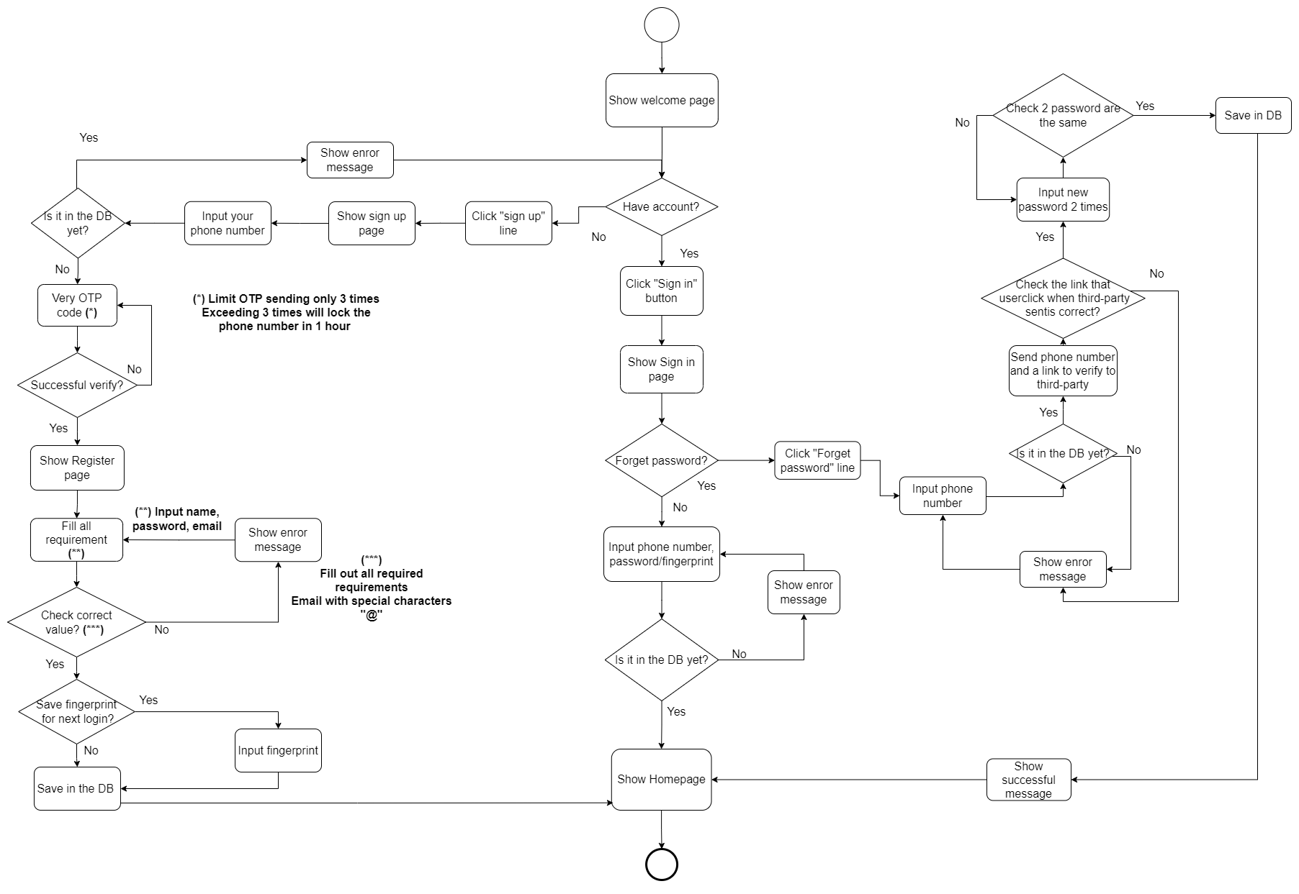

### 

### 2.3.2 Detailed Flow

Users need to log in/register to access the application at the "Welcome" page.

**Case 1: User does not have an application account**

The user will click "Register" to create an account. When registering, users enter a phone number for the system to check.

If the phone number has been previously registered, the system will display an error message. If the phone number has not been registered, the system will connect with a third party to send an OTP code via the user's phone number for confirmation. The system requires the user to enter the OTP code to confirm.

* If OTP authentication fails, the user will request the system to send a new OTP code. The system stipulates that OTP can only be resend a maximum of 3 times. When the specified number of times is exceeded, the user's phone number will be locked for 1 hour.
* If OTP authentication is successful, the system will display the registration screen and ask the user to enter the necessary information to register an account. If the registration information (name, email, password) is incomplete or the user enters the wrong email format (missing the @ character), the system will display an error and a red border in the incorrect input field after the user completes it. into the step of entering information.

Next, the system asks if the user wants to save fingerprints. Otherwise, the system skips this step. Or the system will request permission to take fingerprint data to save if the user agrees to save the fingerprint. Then, the system creates a new account for the user. Finally, the system saves the user's account information into the database and completes the account registration, displaying the Home Page.

**Case 2: User already has an account**

The user clicks "Sign In" at the Welcome page to sign in with their phone number and with their fingerprint or password.

Then the system checks the information in the database. If it is, the app displays the Home page. If the account is not in the database, the system will display an error message and return to the "Login" page to log in again.

In case the user forgets the password, the user can request to create a new password. When clicking "Forgot password", the user will be asked to re-enter the phone number. The system checks whether the phone number is in the database or not.

If not, the system will display an error message. If available, the system will connect with a third party to send a confirmation link to the user's phone number for the user to click on to create a new password by entering the new password twice.

## 2.4 Manage Patients Profile

After users log in or register for the app and access the "Welcome" page, they can verify whether they have successfully created an account.

### 2.4.1 BPMN

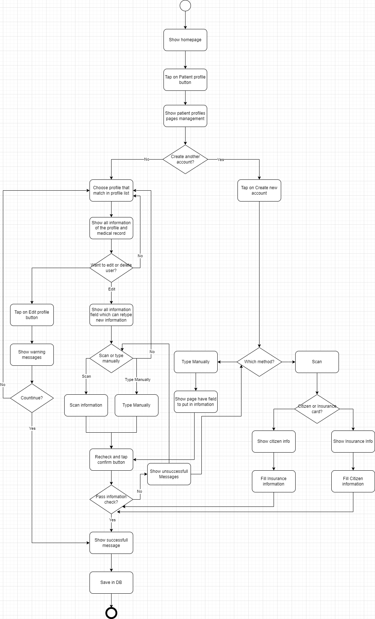

### 2.4.2 Detailed Flow

After the user taps on the “Patient Profile” button on the homepage, the application will show “Patient Profile Management” pages.

**Cases 1: The user already have an account**

When accessing the application's homepage, users have the option to review and select from their previously created profiles. Once a profile is chosen, users can choose to view either user information or previous medical records. Tapping the "User Information" button will reveal details about the user, their relatives, and the complete history of medical schedules.

**Case 1.1: The user want to edit the “Patient Profile”**

To modify this information, including updating user details or health insurance information, users can tap "Edit Profile," input the necessary changes, and then tap "Continue" to review and either confirm or go back for further editing.

Upon confirming the edits, the application will notify the user of the successful update.

**Case 1.2: The user want to delete the “Patient Profile”**

Alternatively, users can delete a profile by tapping "Delete Profile," confirming the action, and saving changes to the database upon success. After that, the system will prompt the user with a message asking whether they want to create a new profile. If the user chooses to create a new profile, they can proceed with the creation; otherwise, the system will navigate back to the homepage.

**Case 1.3: The user want to view the “Medical Records”**

To access medical records, users can tap the "Medical Records" button. If it's their first time, the application will prompt users to enter an OTP sent to their phone number. After OTP verification, all medical records associated with the user will be displayed.

**Case 2: The user doesn't have a profile**

To register for an account, users click the "Create New Profile" button and provide their phone number. The system checks if the number is already registered; if so, an error message is displayed. For unregistered numbers, the system connects to a third-party service to send an OTP code to the user's phone. After entering the OTP code for verification, users proceed with the registration process based on the method chosen:

**Case 2.1: Patient create new account using Information Method:**

Users input their information, and if it doesn't match the database, they are prompted to review and re-edit. If they choose not to re-edit, they can confirm and continue. A warning is displayed if they select to re-edit, asking if they want to refill and recheck the information.

Upon completion, the system saves the user's account information to the database and directs them to the main page, marking the successful completion of the account registration process.

**Case 2.2: Patient create new account using Health Insurance Method:**

Users can choose to either scan the QR code on their health insurance card or manually input the information. After confirmation, the app checks the user information in the database. If it's not found, the user can proceed to fill in additional information and review the details added through the scan. Once completed, the user has successfully created an account.

Upon completion, the system saves the user's account information to the database and directs them to the main page, marking the successful completion of the account registration process.

**Case 2.3: Patient create new account using Citizen Identification Card Method:**

Users can scan the QR code on their citizen identification card or manually input the details. After confirmation, the app checks the user information in the database. If it's not found, the user can proceed to fill in additional information and review the details added through the scan. Once completed, the user has successfully created an account. If a match is found, a warning asks if they want to log in using the "forgot password" option.

Upon completion, the system saves the user's account information to the database and directs them to the main page, marking the successful completion of the account registration process.

## 2.4 Booking

### 2.4.1 BPMN

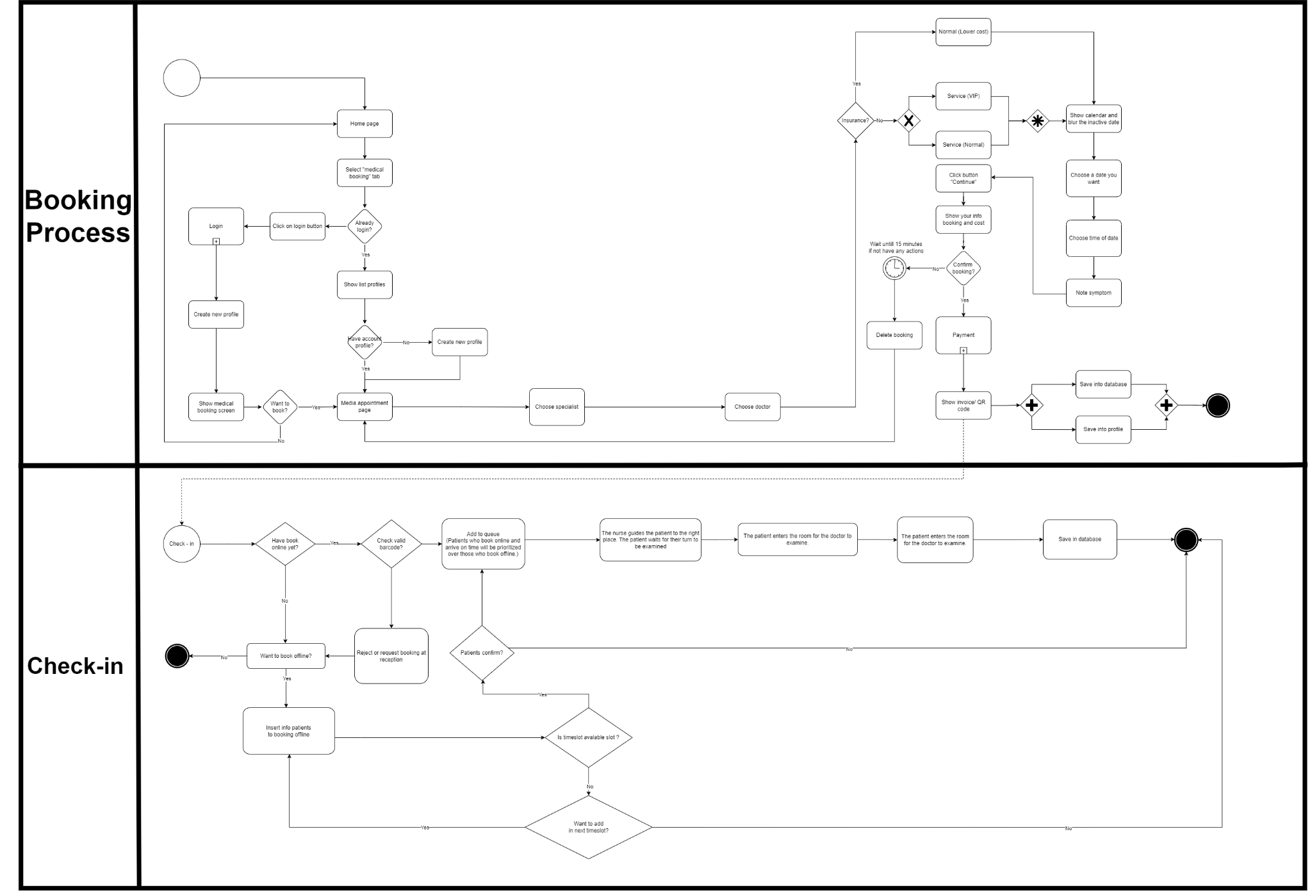

Booking BPMN

### 2.4.2 Detailed Flow

**Case : Have not Login yet**

The booking procedure begins at the homepage of the medical service platform, where users are presented with various options, including a tab specifically for "medical booking." This user-friendly interface allows users to access the booking system seamlessly. Should a user not be logged in, they are prompted to do so by clicking on the login button. This action leads them to a decision point: they can either enter their login credentials if they are returning users or create a new profile if they are new to the system. This step ensures that all user information is securely stored and retrieved for the booking process.

**Case : Have Logged**

Once logged in, the system displays a list of profiles associated with the user's account, allowing them to select the appropriate profile for the booking. This is particularly useful for users who manage appointments for multiple people, such as family members.

**Case : Making an appointment**

If the user decides to book an appointment, they are directed to a dedicated appointment page. Here, they can start by inputting the name of a desired hospital or use a variety of filters—such as location, specialization, and other hospital-specific criteria—to refine their search for the most suitable medical facility. This filtering process is designed to be intuitive, providing users with a high degree of control over their search parameters.

Upon filtering, the system displays a list of hospitals. Depending on whether the user inputs a specific hospital name or uses filters, they may see all hospitals in the database or just those that meet their criteria. From this list, the user selects a hospital and proceeds to click on the booking button, which navigates them to a page with various booking options.

This page enables the user to choose a medical specialist from a list of available options, further allowing them to personalize their medical experience to their specific needs. In some cases, users may also have the option to choose a specific doctor, adding another layer of customization to their booking.

The next step in the process requires the user to confirm whether they have medical insurance, which determines the type of service they are eligible for—either a standard service at a lower cost or a VIP service for a premium experience. This decision affects the subsequent steps in the process.

Once the service type is selected, a calendar is displayed, showing available dates for appointments. Inactive dates are blurred out to guide the user towards choosing a viable appointment date. After selecting a date, the user then picks a specific time slot and is prompted to note any symptoms they may have, which can provide preliminary information to the healthcare provider ahead of the appointment.

**Case User didn’t confirm the booking**

Following these selections, a summary of the booking information—including the cost—is presented to the user for review. The system implements a time-sensitive feature where if the user does not take any further action within 15 minutes, the booking is automatically deleted to free up the slot for other potential patients.

**Case: User confirmed the booking**

If the user confirms the booking, they move on to the payment phase, where the medical examination fee is shown and payment options are provided. This step ensures that all financial transactions are handled securely and efficiently.

To complete the booking process, all information regarding the appointment is saved into the database, ensuring that the hospital and medical staff are informed of the upcoming appointment. Additionally, the details are saved into the user's profile for easy access and management of their appointments.

This comprehensive booking process is designed to be user-centered, offering a step-by-step approach that guides users through each decision point, ensuring clarity and ease of use. The system's design prioritizes user convenience and aims to streamline the often complex process of medical bookings.

## 2.5 View Booking Schedule

### 2.5.1 BPMN

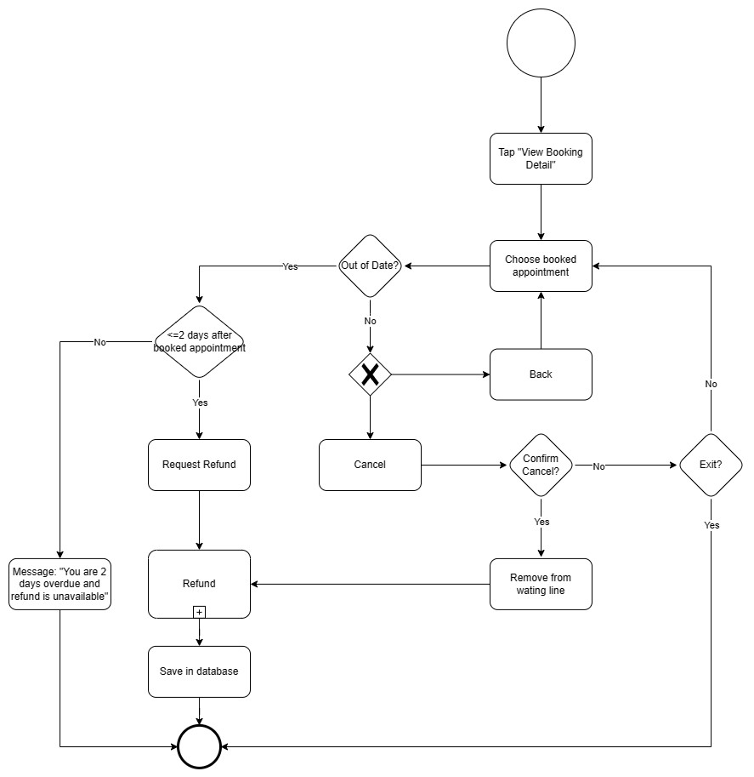

**Figure 2.X - BPMN View Booking**

### 2.5.2 Detailed Flow

There is a "View booking details" button on the app homepage. The user starts the process by clicking that button. It will display a list of booked appointments and the user selects 1 to see details. Once selected, detailed information about the selected booked appointment will be displayed. Users can check if an appointment is out of date.

**Case:** If the appointment hasn't happened yet, display 2 buttons: "Cancel" and "Back".

- "Cancel" button: allows users to select the "Confirm cancellation of your appointment" button. After that, the system will remove your appointment from the waiting list and refund, save it to the database and end the process.

- "Back" button: Asks if the user wants to see other booked appointments? No, end of process. Yes, return to the page showing the list of booked appointments.

**Case:** The appointment is overdue but not more than 2 days. Allow the user to select "Request Refund" and initiate the refund and end the process

**Case:** The appointment is more than 2 days overdue. Displays a notice that it is overdue and cannot be refunded.

## 2.6 Payment

### 2.6.1 BPMN of Payment

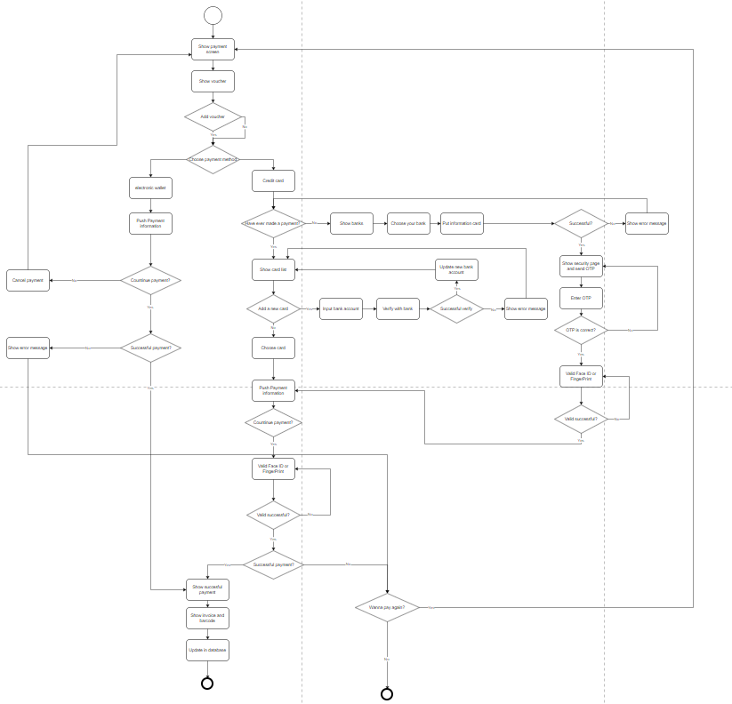

### 2.6.2 Detailed Flow

**Payment Process for Existing Application Users**

**Starting the Payment Process:**

* Users begin by accessing the payment page after selecting their desired product or service.

**Voucher Selection:**

* Customers choose a voucher they wish to apply for the payment, if they have any available.

**Choosing the Payment Method:**

* Customers select one of two supported payment methods: Electronic Wallet or Credit Card.

**Case 1: Electronic Wallet**

* Customers are shown details about the payment information and can choose to either continue with the payment or cancel it.
* Payment Authentication: If authentication fails, an error message is displayed. Customers can try again or choose a different payment method. If authentication is successful, the process continues.

**Case 2: Credit Card**

**Starting with Payment Method Selection:**

* If the user selects "Credit Card" as their payment method, the system inquires whether they have made payments using a card before.
* If "Yes," the system displays a list of saved cards. Users can add a new card or select an existing one. For new cards, users input card details and select it.
* If "No," users are allowed to add new cards.

**Bank Selection and Verification:**

* Users are prompted to "Choose your bank" and input their card information.
* The system attempts to verify the card with the bank. If verification is unsuccessful, an error message is displayed. If successful, the system updates the new bank account details.

**Security and OTP Verification:**

* A security page is displayed, and a One-Time Password (OTP) is sent to the user.
* Users enter the received OTP. If incorrect, an error message is shown. If correct, the process proceeds to the next step.

**Biometric Verification:**

* The system requests face ID or fingerprint verification.
* If biometric verification fails, the process ends unsuccessfully. If it succeeds, the process continues.

**Payment Execution:**

* Payment information is submitted to the system.
* Users are asked whether to "Continue payment." If "No," the process ends. If "Yes," the system processes the payment.

**Final Verification and Completion:**

* The system performs a final check. If the payment is unsuccessful, the process may end or loop back to an earlier step for correction. If successful, the payment is completed.

## 2.7 Refund

### 2.7.1 BPMN of Refund

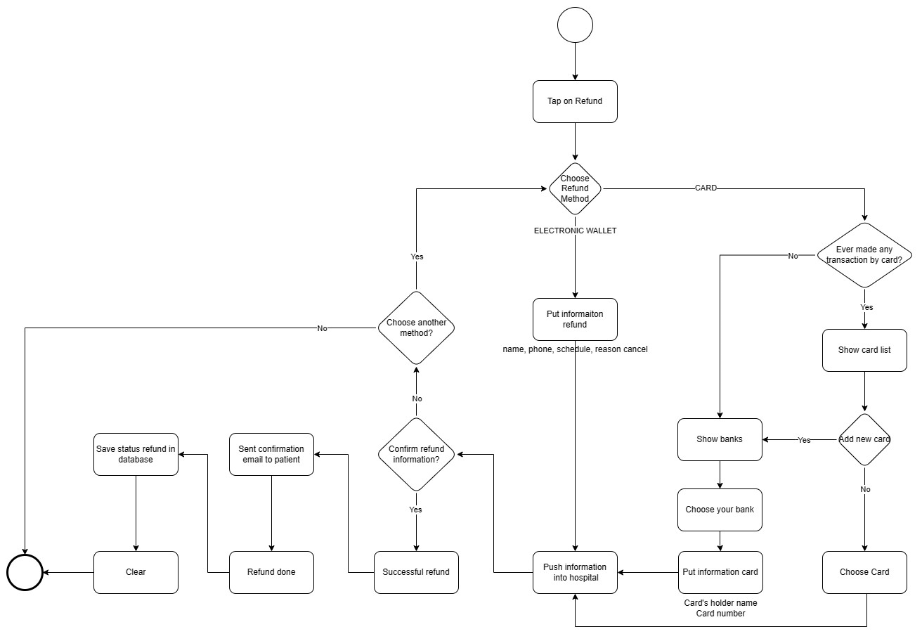

**Figure 2.x - BPMN of Refund**

### 2.7.2 Detail flow of Refund

After the user reviews the appointment schedule in the "View Booking Detail" step and if it is expired, the system checks whether the appointment has already been paid for. If it has been paid for, the system provides paid users with the option to select the "Request Refund" button. Subsequently, the system processes the refund.

When users choose the "Refund" button, they will be presented with two refund methods based on their original payment method: Bank Card and Electronic Wallet.

**Case Refund by card:** The application will ask if the user has ever used a bank card to pay on the application?

- If yes, will ask additional users if they want to add new tags. If you create more, select a bank, fill in information related to the selected bank, then the information will be transferred to the hospital to check and begin refunding to the user. If no more are created, the user selects an existing bank card and waits for a refund from the hospital.

- If not, the user selects the bank, fills in information related to the selected bank, then the information will be transferred to the hospital for checking and initiating a refund to the user.

**Case Refund using e-wallet:** Users choose to fill in information related to their e-wallet and refund information, then the information will be transferred to the hospital for checking and starting to refund the use.

Once the money has been refunded to the user, the completion information will be saved in the hospital database

# 

# Chapter 3. Detailed Analyses

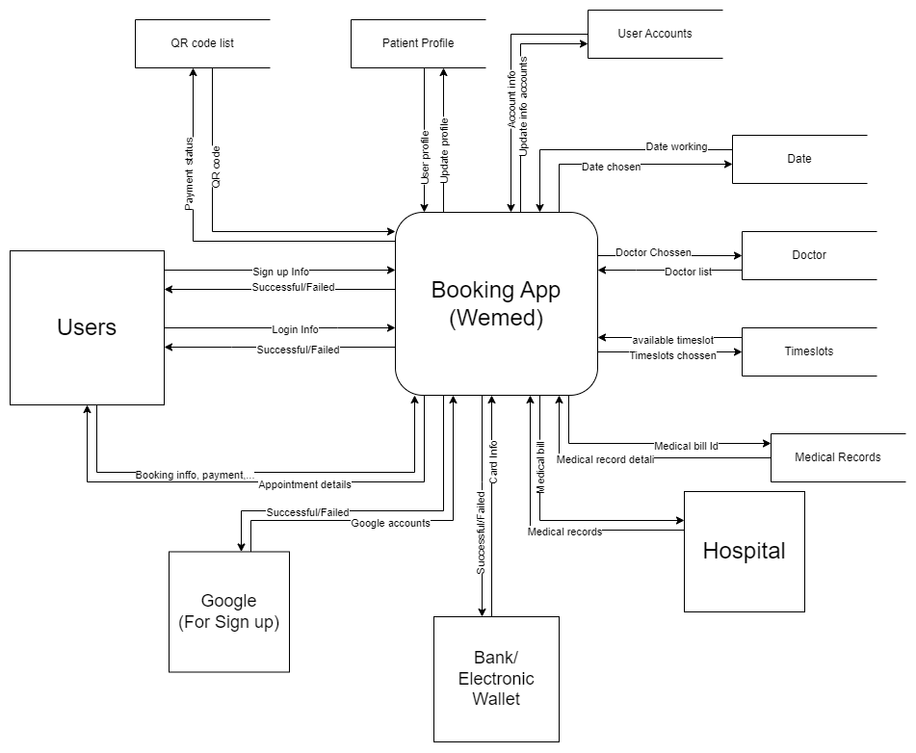

**DFD Level 0**

## 3.1 Login and Sign up

### 3.1.1 Descriptions

In order to use the application and make appointments, each user needs to create an account. The account creation process requires users to enter personal information to facilitate the most convenient management.

This feature provides the ability for users with existing accounts to log in, making it easy for them to schedule appointments. If users do not have an account yet, they can also register for a new one. Additionally, users have the option to reset their password if they forget their login credentials.

### 3.1.2 Data Flow Diagram (DFD)

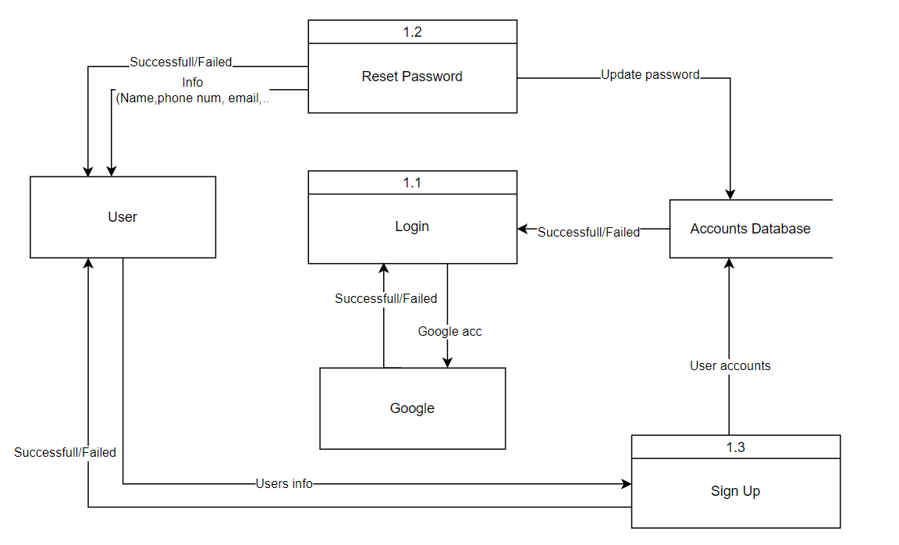

**Login/Signup DFD**

There are three processes in this function: Register, Login and Reset password.

* **Register**: In this process, the users enter their required information. This information will be inserted into the list of current accounts if it has not existed for any account before. Then, the system will respond to the users that creating a new account is successful or fail.
* **Login**: In this process, the users enter information about their account (phone number/ email address and password). Then, the system will check the list of current accounts. If this information has existed, the system will respond to the users that the process is successful. Or else, the process fails. To be faster, the users can even login with Google. The system will connect to their Google account. If it has existed, the process will be successful. Or else, it will fail.
* **Reset password**: This process will be used when the users forget their password and want to reset password. Firstly, they need to fill in information about their account like phone number or email address so that the system can find their account. Then, the system will check this information in the list of current accounts. If there is an account with this information, the system allows users to 28 set a new password. Finally, the system will update the new password of the users which has been changed to a database and respond to the users

### 

## 3.2 Profile Management

### 3.2.1 Descriptions

The Patient Profile Management System is a comprehensive solution designed to streamline the administration of patient information within healthcare settings. This robust platform enables medical professionals to effectively manage patient profiles, ensuring that pertinent health records, personal information, and medical history are meticulously organized and easily accessible.

### 3.2.2 Data Flow Diagram (DFD)

### Profile Mangement DFD

If a patient wishes to create a new profile, they will enter the necessary patient information into the available fields. This information will undergo a validation process. After successfully passing the validation, the system will check these details against the app and hospital database. Subsequently, a unique ID will be assigned to the patient, and a notification will be sent confirming the successful creation of the profile.

In the case where a patient already has a profile and wants to update their information, they will submit an update request through the verification process. If the verification is successful, the information will be entered into the app and hospital databases for verification and will overwrite the original data. A notification will be sent to confirm the successful update.

If a patient with an existing profile wishes to delete their profile, they can press the delete button. The app will then confirm whether they are sure about the deletion. If the user proceeds, the app will delete the user's data from the hospital database and provide a notification confirming the successful deletion.

For a patient with an existing profile who wants to view all appointments, they can select the profile they wish to view, press the "View Appointment History" button, which will trigger a request to the app and hospital database. The databases will then return all upcoming and past appointments for that user.

## 3.3 Booking

### 3.3.1 Descriptions

The function to create a consultation schedule helps users when they want to reserve before the examination time. With this function, the user provides information about them, their demand about appointment, the application will suggest information about doctors, department, and working date, hours for users to refer to and choose the appropriate choice. Then the user can choose to pay the medical cost directly on the application or not.

### 3.3.2 Data Flow Diagram (DFD)

### Booking Process DFD

The Data Flow Diagram (DFD) for the booking process in the hospital management system illustrates a multi-step approach to handling patient appointments and associated financial transactions. Initially, patient information is input into the system, where it is then managed within the "Patient Profile" process, allowing for the retrieval and updating of patient records as necessary. This information flows into the "Manage Booking Records" process, where available schedules are checked against patient requests to align bookings with open time slots. These bookings are recorded within a dedicated "Schedule Database."

Once a booking is initiated, its status is actively monitored by the "Monitor Booking Status" process, which tracks bookings through various stages, including pending actions such as awaiting payment. The booking data, meanwhile, is held within a "Booking Database" which serves as a repository for all booking-related transactions. Payments for bookings are managed through the "Manage Transactions" process, which also generates booking invoices that can be saved as historical records for future reference.

Finally, the "Report and Invoice" process takes over to compile booking-related reports and manage accounting details. This includes generating financial reports and detailed accounts of completed bookings, ensuring that all financial aspects of the booking process are well-documented and transparent. This comprehensive system aims to facilitate a seamless and efficient booking experience for patients while maintaining accurate and up-to-date financial records for the hospital administration.

## 3.4 Payment

### 3.4.1 Descriptions

### 3.4.2 Data Flow Diagram (DFD)

### 

There are three main processes: Adding New Card, Payment, and Payment Verification.

* **Adding New Card**: Users will submit their card information to the application, which will then validate with the bank whether the card is valid or not. If the card is valid, the user's card will be added to the database.
* **Payment:** Users will proceed to make a payment using the payment information provided by the application, through either a Credit Card or an electronic wallet.
* **Payment Verification:** After the user makes a payment, the system will verify with the bank or electronic wallet to confirm whether the user has paid and whether the payment was successful or not.

## 3.5 Refund

### 3.5.1 Descriptions

Refund is a function that talks about refunding money to users after they cancel an appointment or the appointment is late but not more than 2 days.

### 3.5.2 Data Flow Diagram (DFD)

### 

**Figure 3.x Refund DFD**

We have three functions for the Refund section, which include: Refund Information, Refund Process, and Refund Status.

**Refund Information:** This function sends the user's refund details after their request, retrieving information from the Booking database.

**Refund Process:** The refund process is executed after verifying the information. If the details match those in the Booking section, the money will be refunded to the user; otherwise, it won't.

**Refund Status**: The status of the refund will be displayed to the user (Fail/Successful).

## 3.6 View booking

### 3.6.1 Descriptions

This feature enables users to engage with and handle their appointments. It encompasses three main interactions: viewing appointment details, canceling appointments, and requesting refunds for expired paid appointments.

### 3.6.2 Data Flow Diagram (DFD)

### 

There are three processes: Viewing Appointments, Cancelling Appointments, and Refunding.

**- Viewing Appointments:** It starts with the user's request to view appointments, which then goes to the Booking Details database. The Booking Details database provides all the information about the selected appointment for the process. Finally, the process displays the appointment details to the user.

**- Cancelling Appointments:** It receives the cancellation request from the user and proceeds to send the refund request to the Refund process.

**- Refunding:** It receives refund requests from the Appointment Cancellation process and users whose appointments have expired. Then, it executes the refund, sends the money to the user, and updates the refund status in the Booking Details database.

# Chapter 4. Mock Up



## 4.1 Login/ Sign up

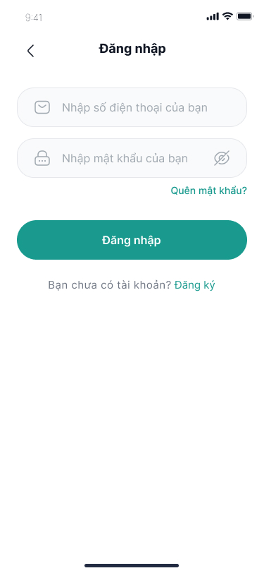

When users open the app, they will be greeted with a friendly and convenient welcome page. This welcome page has the following options:

Login: If the user already has an account and wants to access the application immediately, they can click the "Login" button. They will then be taken to a login screen to enter their credentials and access the app.

“Bạn chưa có tài khoản? Đăng ký”!: For users who don't have an account, they can click on "Don't have an account?, Register" to begin the process of creating a new account. After clicking on it, they will be taken to a registration screen to fill in their personal information and create a new account in the app.

This welcome page is intended to help users easily choose between signing in to an existing account or quickly starting the process of creating a new account.

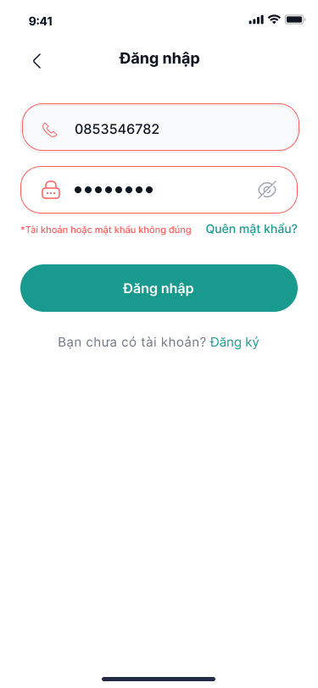

The "Login" heading is at the top of the page, just below, there are two fields to fill in: a phone number and a password, protected by a period. The security feature, the eye icon, allows them to check the accuracy of the password they have entered.

If a user has problems with their login information, they will find the message "Incorrect account or password", they can re-enter or easily access recovery link connections for forgotten password situations. , "Wrong account or password" and another link for "Forgot password?". To complete the process, they simply tap the green "Sign In" button, right below the input fields. For newcomers, there's an enticing "Don't have an account? Sign up" invitation at the bottom of the page, encouraging them to join the app's user community.

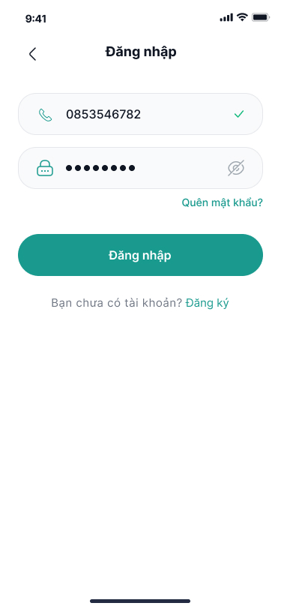

When the user enters the correct password, The system has validated the user's login information is correct and exists in the database. This helps users determine that they have logged in successfully.

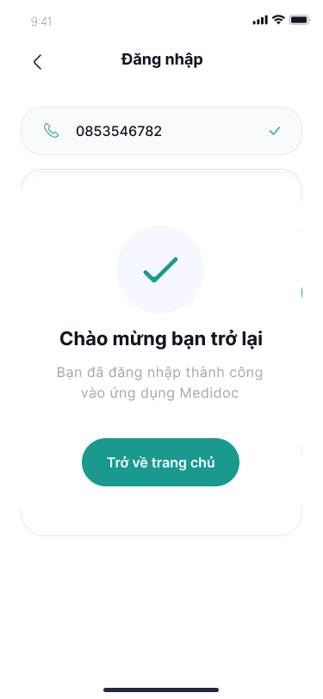

"For users who do not have an account yet, they need to click on the 'Log in' button to create a new account. Once the registration page appears, users must fill in all the required fields, including username, phone number or email address, password, and password confirmation."

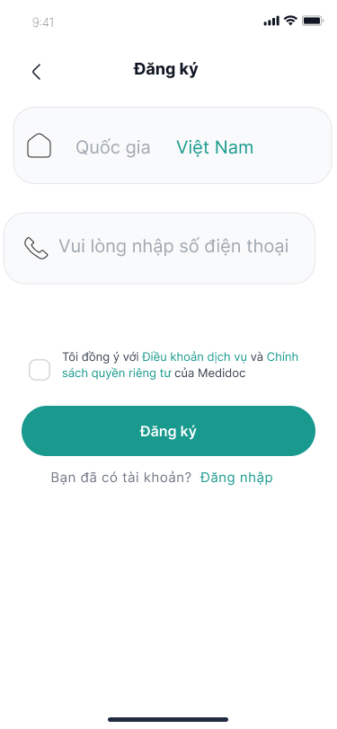

Asking the user to select a country and enter a phone number helps the app authenticate the user's identity.

The app requires users to enter their phone number to create an account. The phone number will be used to send the authentication code to the user. Once the user fills in all the fields with the correct format, the system sends it to them verification code to their phone number or email address.

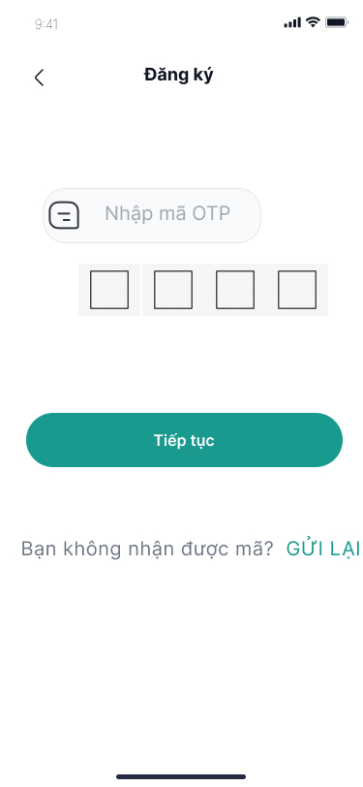

If the users don't receive verification code, they can require the system to send it

again.

The user fills in the OTP and waits for the system to check. If the authentication code is correct, the authentication process is successful. The application will notify the user that "Phone number is valid" and continue the process of completing the registration procedures.

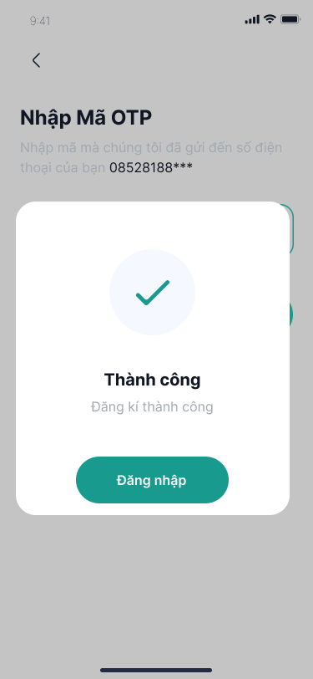

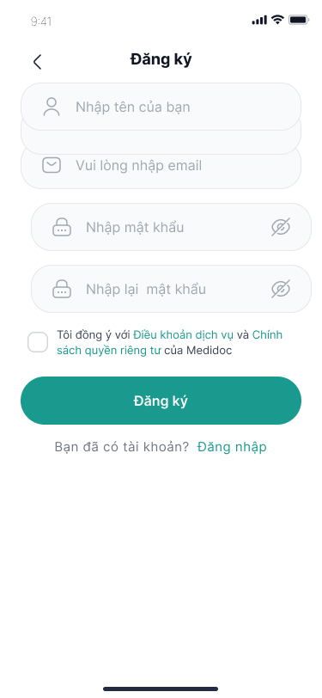

To successfully register an account on the Medidoc application, you need to fill in all the information required by the system. To ensure the speaking registration process is shared, please fill out accurate and complete information. You should also check the information again before pressing the "Register" button.

To register for an account, please provide the following information:

Full name: Enter your full name so that we can identify and create your personal account.

Email address: Input the email address you regularly use to receive notifications and appointment confirmations.

Password: Enter a secure password to ensure the security of your account.

Confirm password: Re-enter the password to ensure accuracy and avoid errors.

After completing the information, the system will confirm and validate the user's account, put that information into the database and display a congratulatory dialogue on completing the registration process.

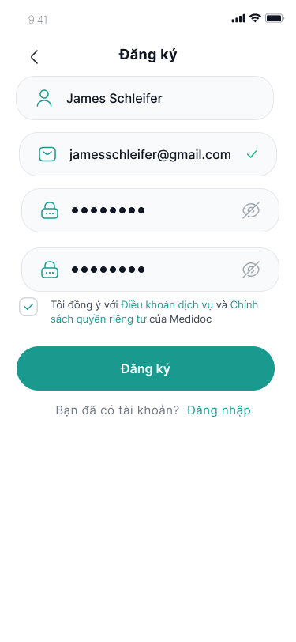

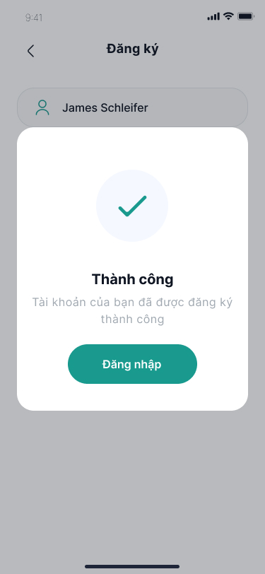

Unfortunately, if users cannot remember their account password, they can use the “Forgot Password” feature in the app to reset it. After completing the password reset process, the application will ask the user to provide the phone number or email registered with their account. Users need to fill out this field so the system can identify and locate their account.



Please note that you must fill in the correct phone number or email information associated with your account. After the system finds the user's account with the information they entered.

The system will send a verification OTP code as the login process. User must enter

appropriate verification code in this field to continue resetting a new password.

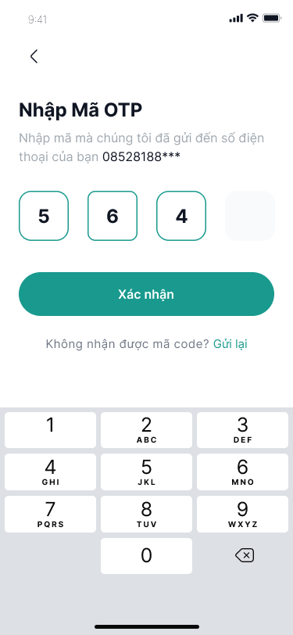

If users input the correct code, they will be prompted to enter a new password and confirm it. If the passwords do not match, the user will be asked to re-enter them. Otherwise, the process will be deemed successful. Subsequently, the application will notify users with a message saying "Password reset successful" and redirect them to the home page.



After Login Successful, the home page will be shown

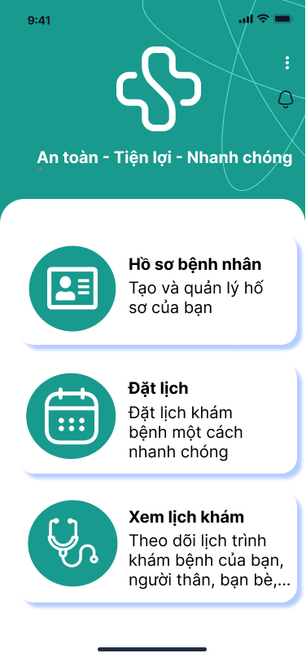

## 4.2 Management

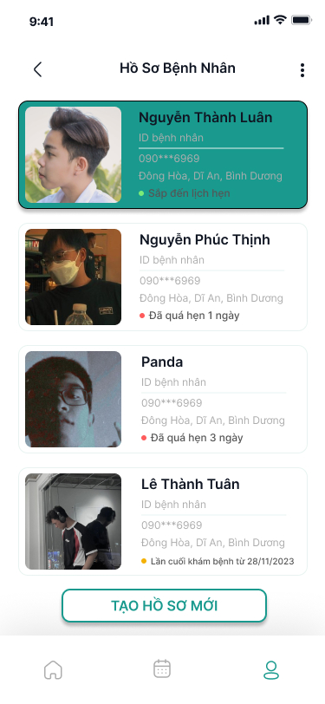

After clicking on the homepage, the patient selects "All Profiles," which will display all the profiles/users created by this account. The patient can then choose the account they wish to view information for.

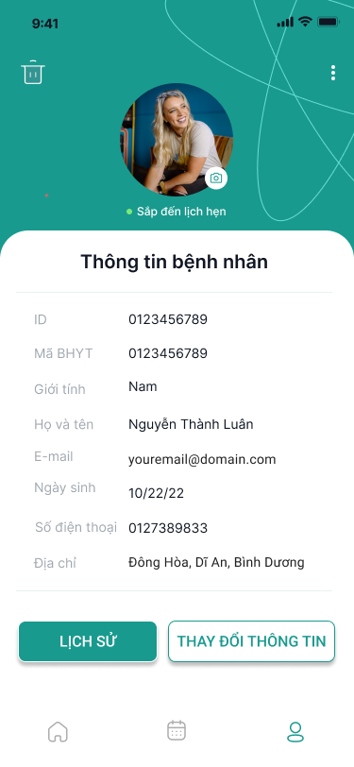

The screen will display the patient's information, allowing for access to the medical history or to update the information. Additionally, you can change your profile picture.

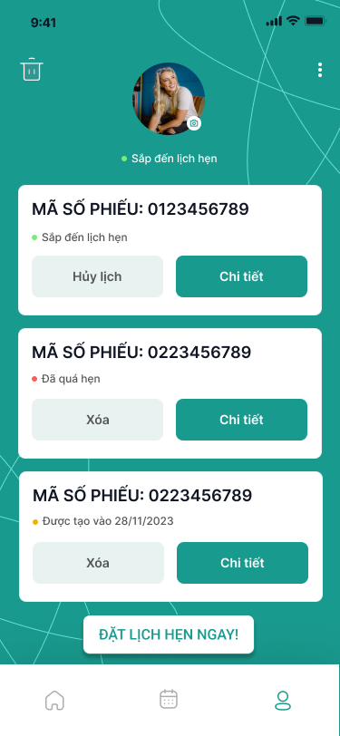

Clicking on "View History" will bring up a list of all the appointments created from the past to the present, with options to either delete or view more details.

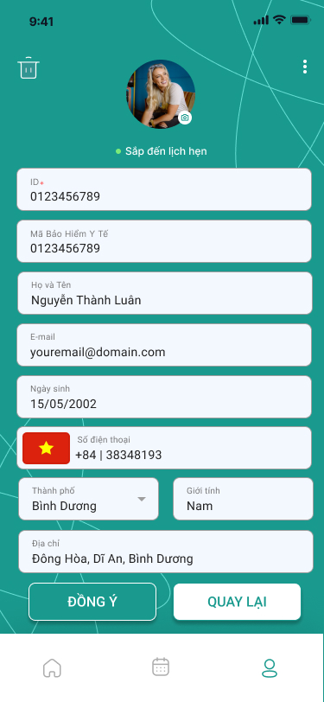

If you click the "Change Information" button, it will bring up fields for you to edit the information. Fields marked with a red asterisk (*) are not editable. Once changes are made, click "Agree" to save or "Back" to discard the changes.

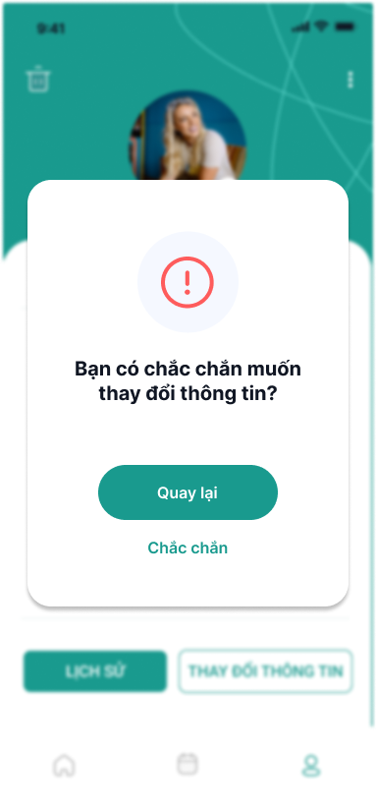

The system will prompt to confirm changes. If you wish to save, press "Confirm"; otherwise, press "Back" to cancel and not save the changes.

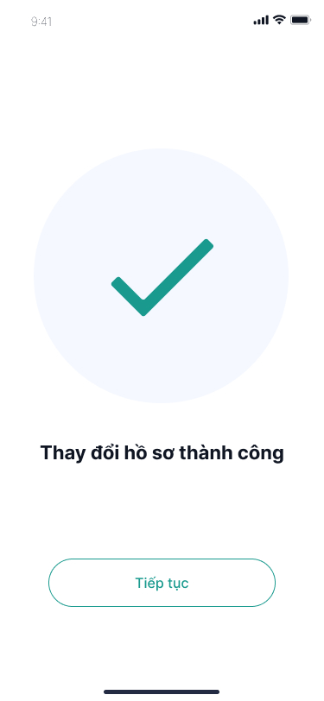

The notification will state that the profile has been successfully updated.

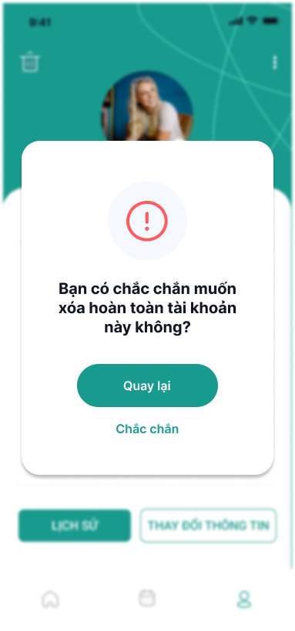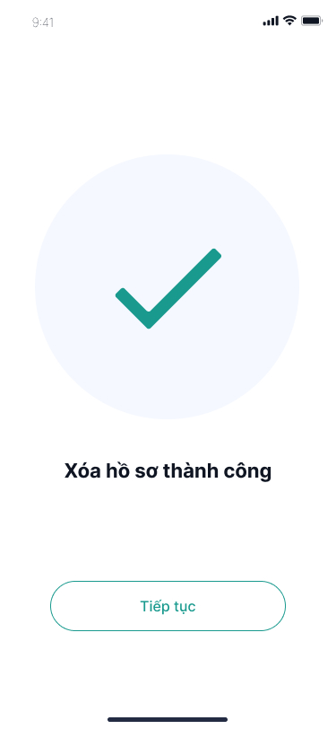

If you wish to delete a profile, click on the trash bin icon. The app will ask if you are certain. If you are, click the "Confirm" button to proceed with the deletion, or click "Back" to reverse the action.

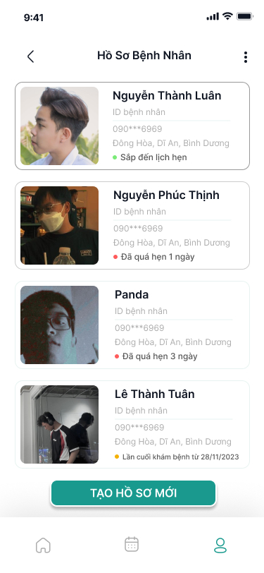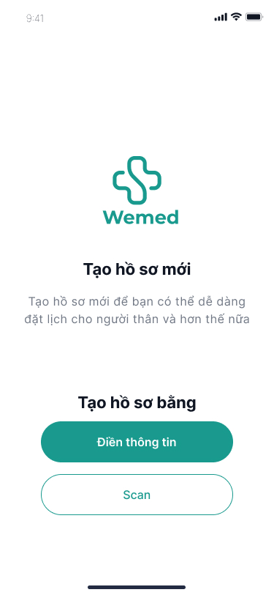

On the all profiles page, click the "Create New Profile" button to create a new profile. There are two steps in the profile creation process: you can either create it by manually entering information or by scanning information. Choose one of these options.

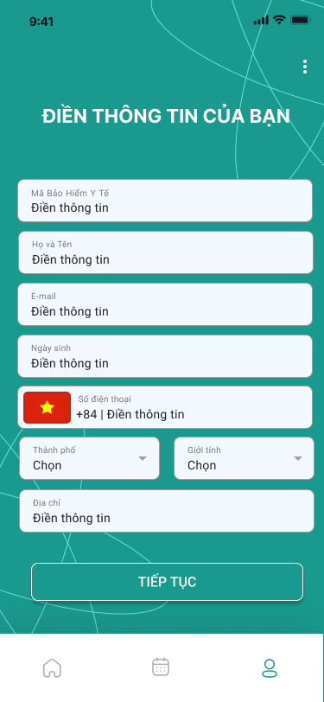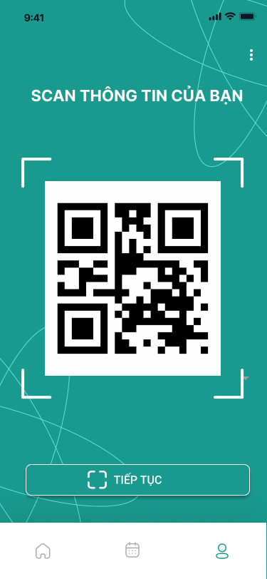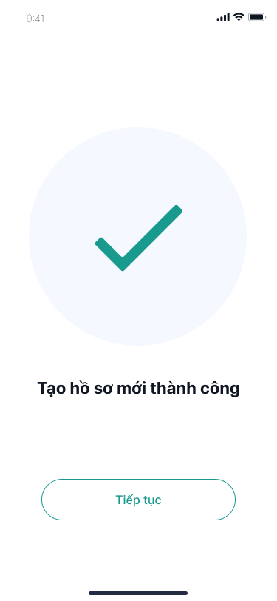

Depending on your preference, select either manual entry or scanning. The relevant fields for information will then be displayed. After completing the fields and clicking continue, a notification will confirm the successful creation of the profile.

## 4.3 Booking

After tapping on “Medical Booking” tab:

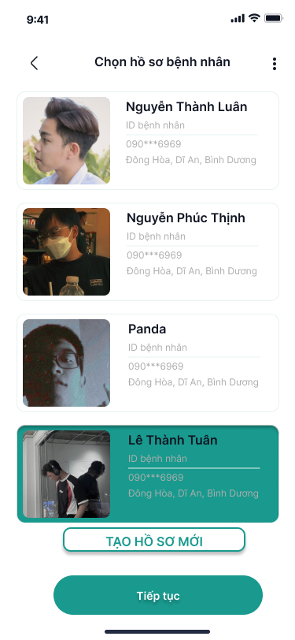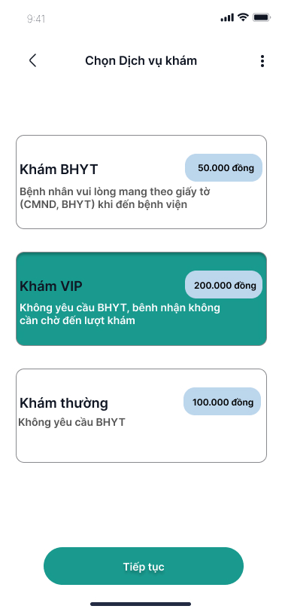

Select the profile that you want to register for to schedule an appointment. If you don't have a profile, you will need to create one to continue the booking process. Once your profile appears in the profile list, you can select it and press the continue button to proceed to the next step. Here, you will choose a medical examination service that suits your needs. You can opt for health insurance examination if you have health insurance or choose a regular examination without the need for health insurance. Additionally, you can select the VIP examination option at a higher cost, but it comes with the benefit of priority when visiting the hospital for your examination.

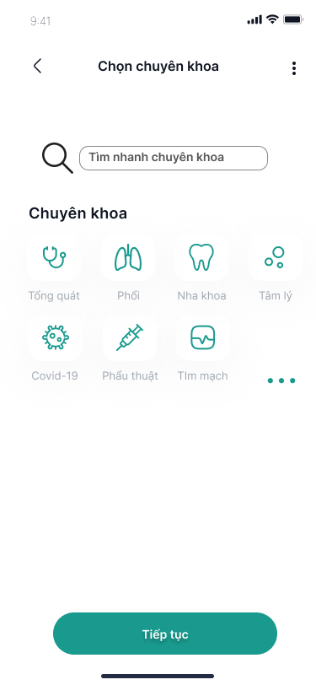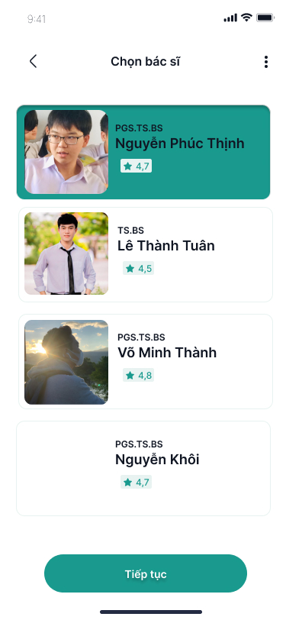

Tap to select the specialist. The application displays a list of the hospital's specialist. In cases where the user is prompted by a suggested department through symptoms, then the user can type his / her symptoms in the search bar.

Then the application shows a list of doctors with working hours of each doctor, so that users can refer to the appropriate examination time. When it comes to finding a doctor by exam time, users can search from a selection of time frames. The application will provide doctors on duty during that time frame or users can search for the doctor they have ever seen.

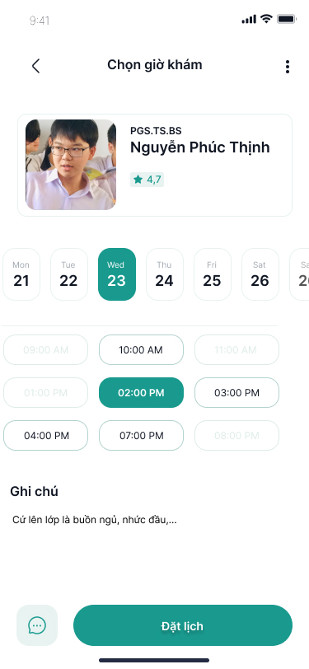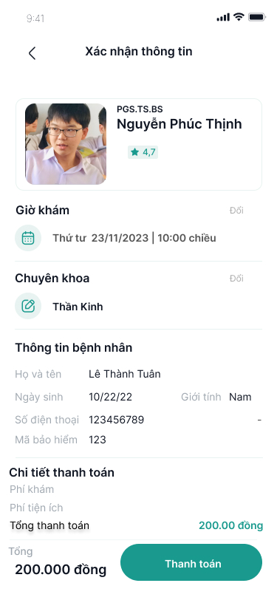

Tap to select the examination date, the application will display the calendar for users to choose the date of the visit. The days selectable will be displayed in green (15 days from the scheduled date), the days unavailable (hospital holidays or not working for any reason) are blur. The date the user chooses will be displayed in green.

Tap on "Đặt lịch", the user will move to the screen to confirm the booking information (Patient information, doctor's information, examination time and total examination cost).

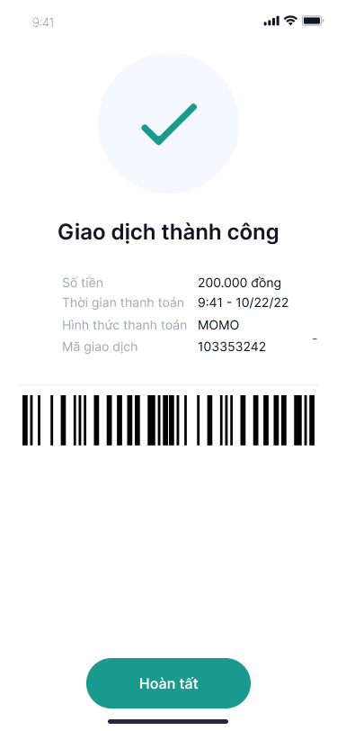

When the transaction is successful, the patient will receive a notification screen confirming the successful payment along with a barcode that can be used to visit the hospital and undergo the medical examination.

## 4.4 Payment

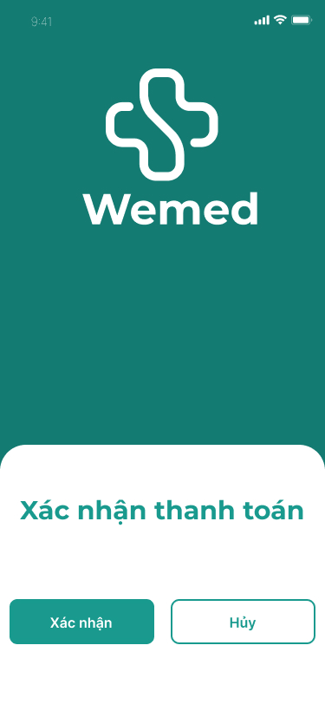

After completing your order, you will be redirected to the payment confirmation page. On this page, if you click the "Confirm" button, you will proceed to payment; if you click the "Cancel" button, you will return to the main screen.

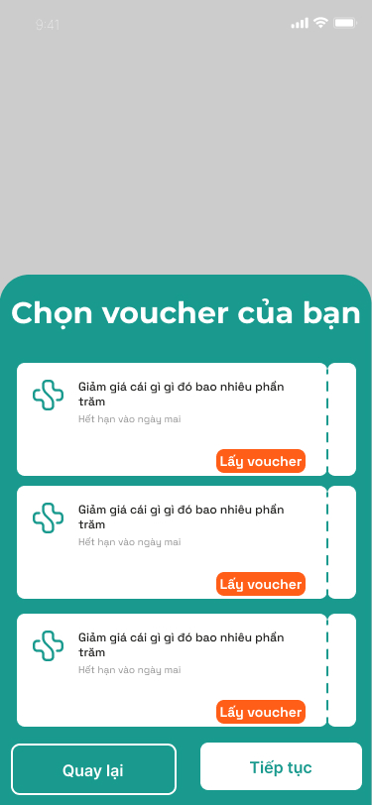

Next, you will arrive at the voucher selection page. Here, you will choose any discount voucher you own and then select the "Continue" button to proceed with the payment. If you do not have a voucher, you will press the continue button to move to the next step. If you wish to go back, you can click the "Back" button.

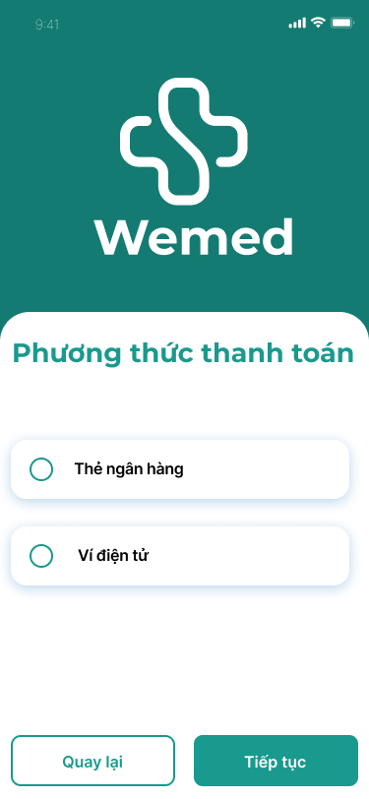

At the next step, you will choose a payment method. The app supports two payment methods: Credit Card or Electronic Wallet. You will select one of the two methods and click the "Continue" button; if you wish to go back, you may click the "Back" button.

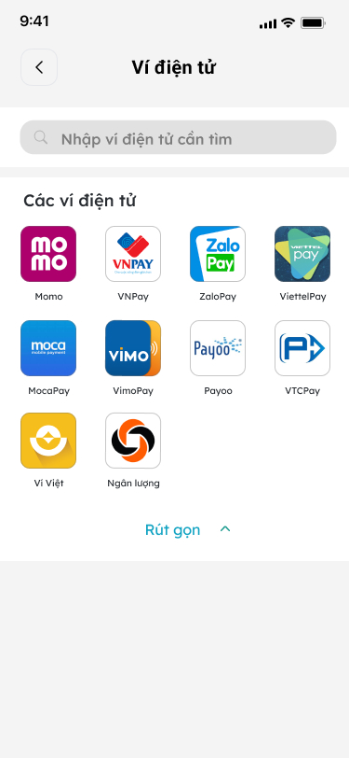

If you choose to pay with an Electronic Wallet, you will be directed to the page where you can select an electronic wallet for payment. This page will display all types of electronic wallets supported for payment. If you do not wish to pay with an electronic wallet, you can click on the back arrow to select a different payment method.

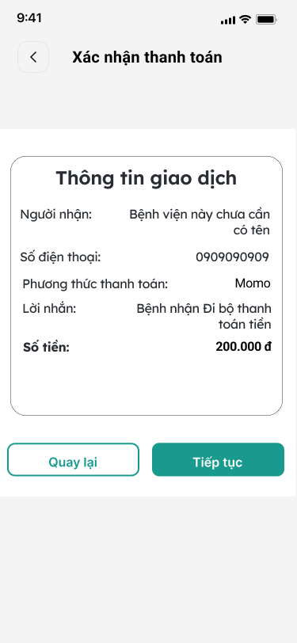

After selecting the electronic wallet, the screen will display payment information including the amount, payment method, etc. If the user agrees to proceed with the payment, they will click the "Continue" button; if not, they will click the "Back" button.

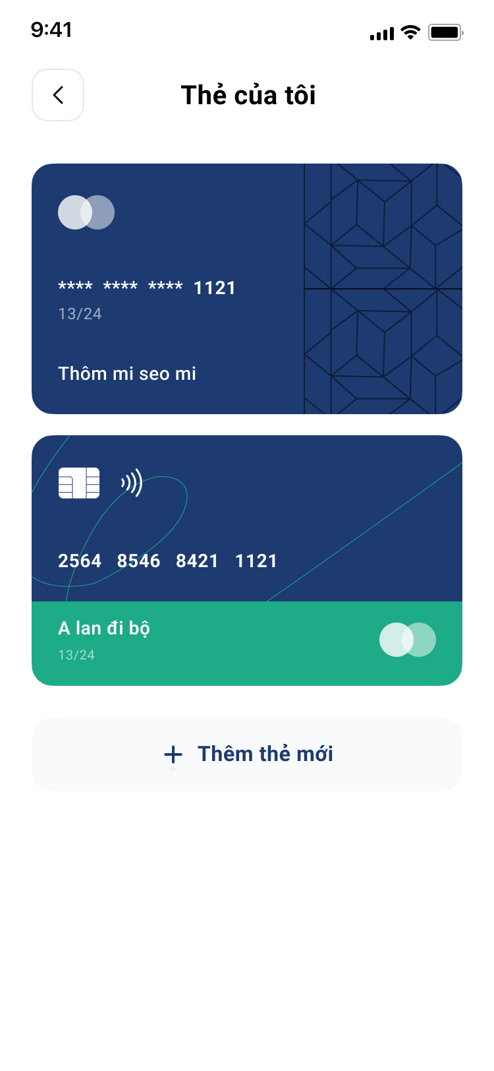

If the user chooses to pay with a Credit Card, they will be directed to a screen displaying a list of Credit Cards that the user currently possesses. Here, the user can select from the Credit Cards they own. If the user wants to pay with a different Credit Card, they will click on the "Add New Card" button.

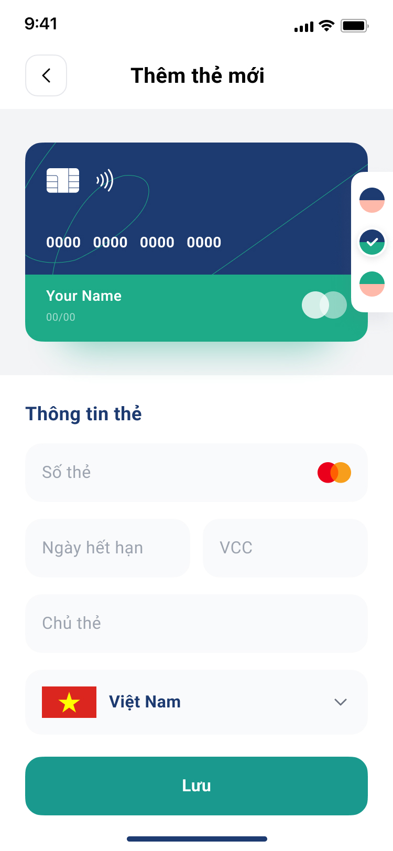

If the user selects the "Add New Card" button, they will be taken to the page to fill in the details of the new card. Here, the user will enter their card information, and after completing the details, the user will press the save button to save their card and continue with the payment.

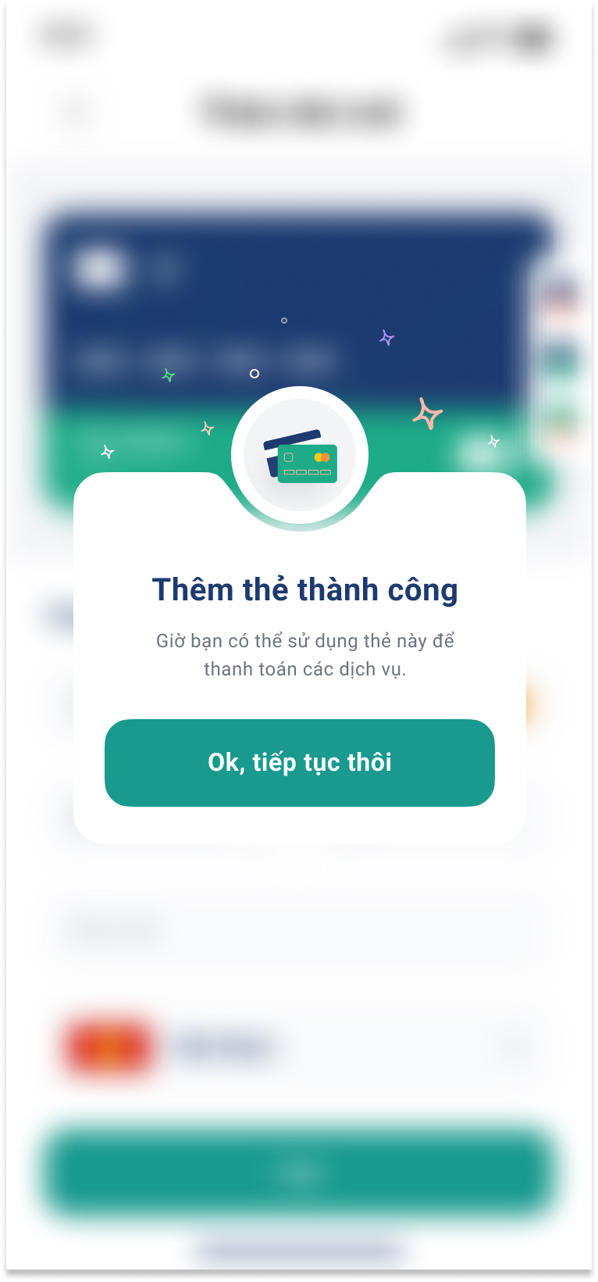

If the information is accurate and verified with the bank, the app will display a screen confirming the successful addition of the card, along with a button to continue with the payment.

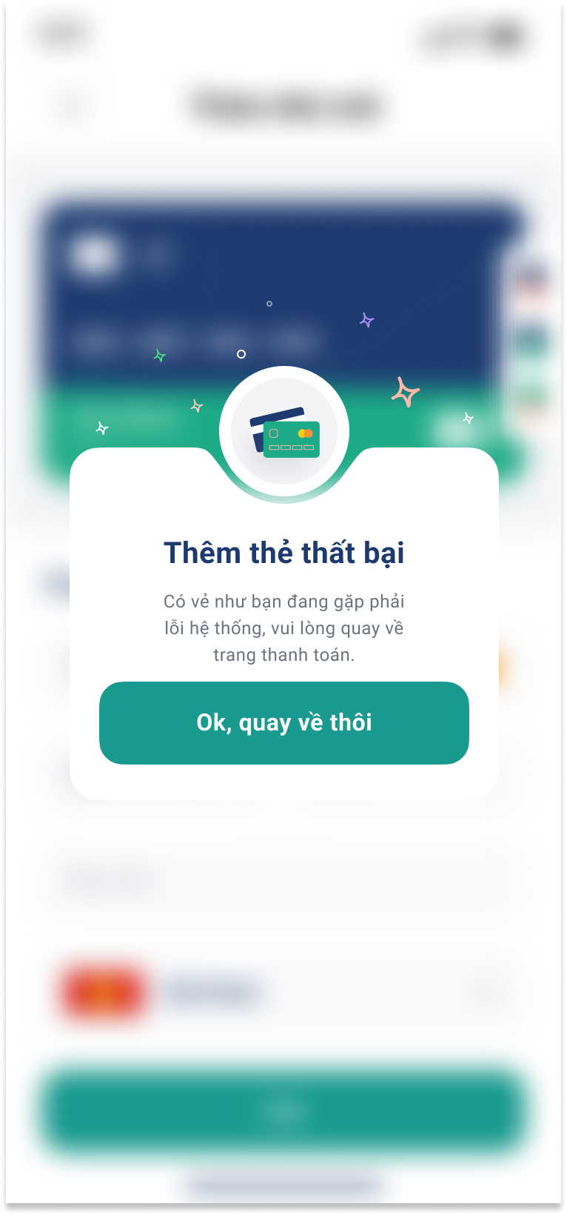

If the information you entered is incorrect or there is an error in authentication with the bank, the app will notify you of the card addition failure and provide a button to return to the payment screen.

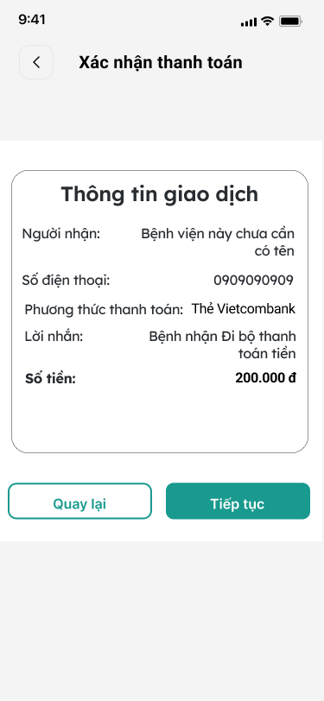

After selecting the type of card for payment, the app will display the payment information. At this step, if the user confirms the payment, they will click the "Continue" button, and if the user wishes to go back, they will click the "Back" button.

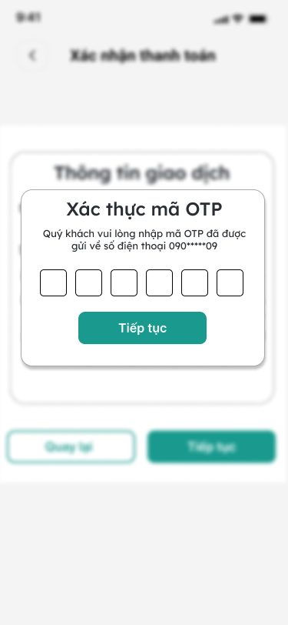

After the user clicks the "Continue" button, the app will send an OTP (One-Time Password) to the user's phone number and display a screen for the user to enter the OTP.

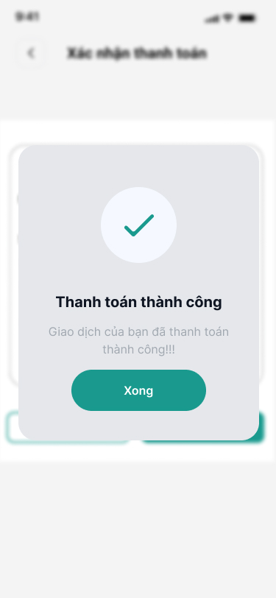

After entering the OTP correctly and successfully completing the payment, the app will display a screen notifying the user of the successful payment.

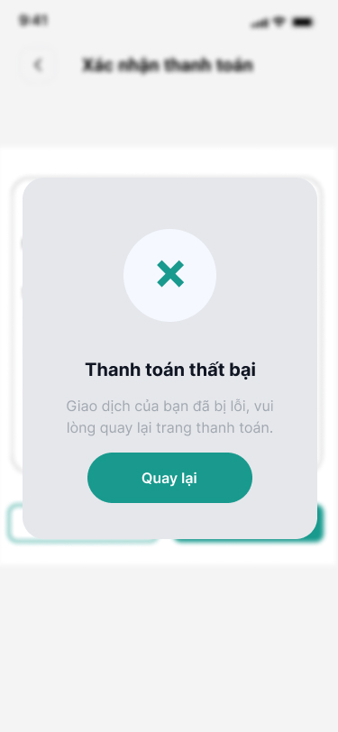

If the user enters the OTP incorrectly or there is an error in the payment process, the app will display a screen notifying the user of the payment failure. The user can click the "Back" button to enter the OTP again.

## 4.5 Refund



When the user presses the "Hoàn tiền" button as in the first interface, information about refunds will appear on the 2nd and 3rd interfaces. In the 2nd interface is refund information when using the bank and the The rest is when using e-wallets.



After the refund process is completed, the user will receive a success notification.

## 4.4 View Booking



Here is the interface when customers want to review their booked appointments. There will be three possible cases: upcoming appointments, appointments overdue by less than 2 days, and appointments overdue by more than 2 days.



The image above illustrates when you want to cancel a medical appointment. The system will prompt you to provide a reason for cancellation, and afterward, your appointment will no longer exist within the system. The amount you paid will be automatically refunded to the account you initially used for payment.

**Link diagram**

**BPMN:**

<https://app.diagrams.net/#G1l3vRBsqWu18DXdI7ymtiAESs38Z91oSb>

**DFD:**

<https://drive.google.com/file/d/1jt2TR7etehXFpFB7aitQe0ASTZQMOBit/view?usp=sharing>